# CS 255 System Design Document Template

## UML Diagrams

### UML Use Case Diagram

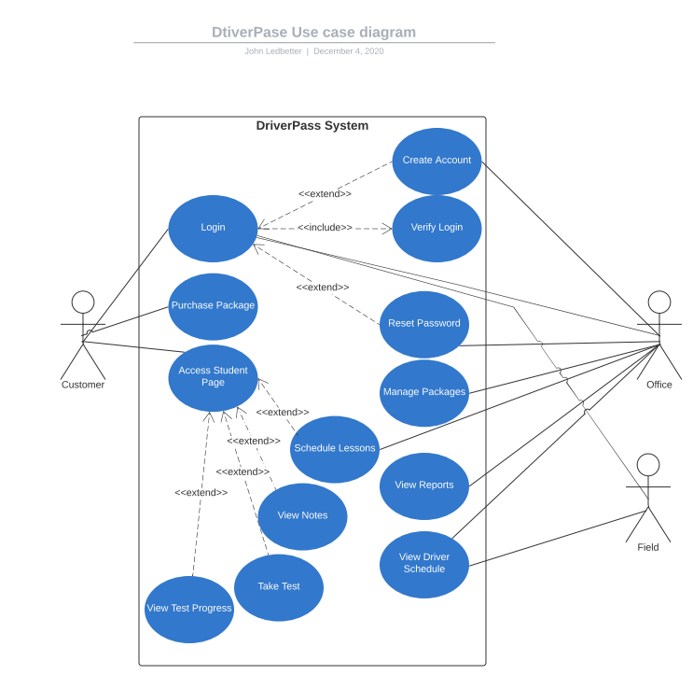

### UML Activity Diagrams

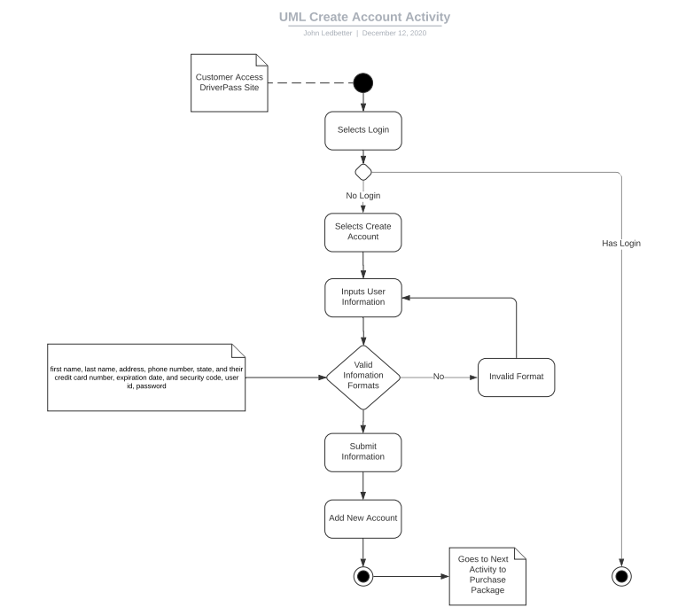

Note: I was unsure if I should or should not have represented the option of login or not. Went with deciding to represent as the login use case would also validate if the customer has an account and could take them to the create account activity if they do not.

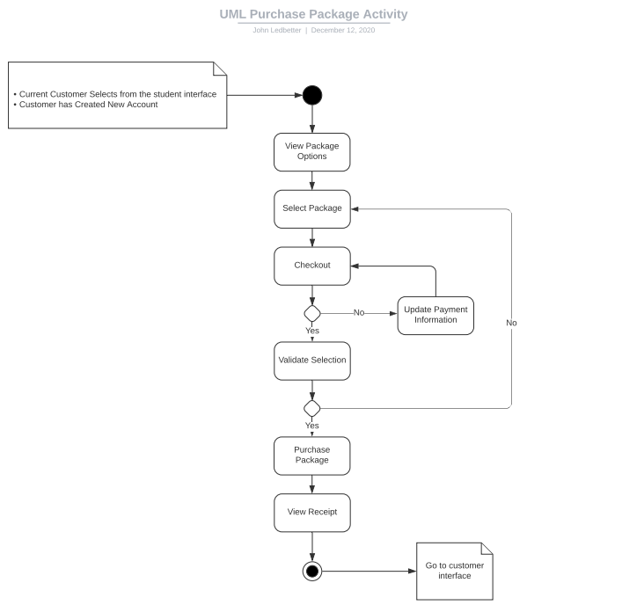

### UML Sequence Diagram

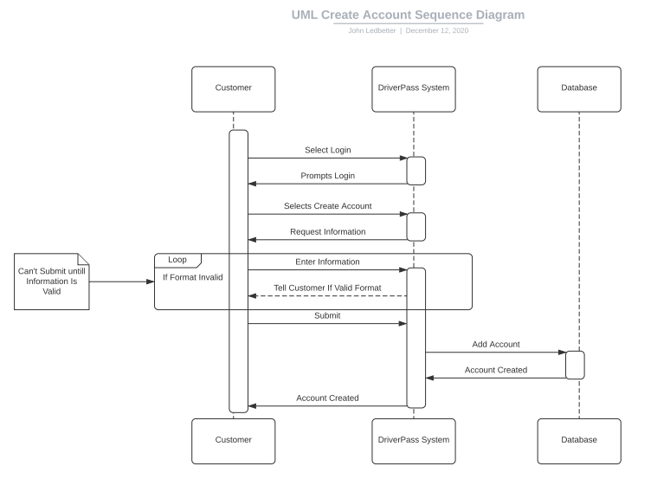

### UML Class Diagram

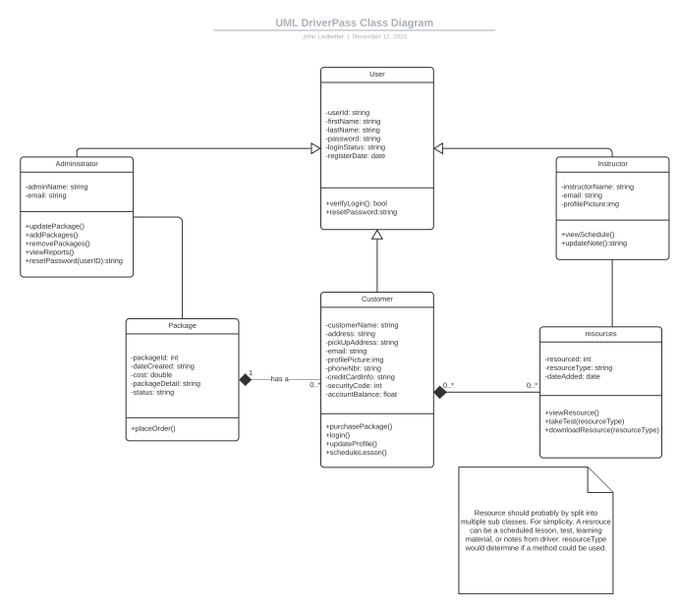

## Technical Requirements

The DriverPass System will require a database storage system to hold user information, package data, lesson schedules, lesson notes, and tests. There will also need to be a file system to store downloadable documents, user profile pictures, and website images. A cloud-based system is requested and will resolve the availability issue (always-on). The system should allow for access to multiple browser types. Regular updates will be made to the DMV through an API connection to keep documents and test up-to-date. A secure payment system should be selected to process payments in real-time and inform the customer of charges. The system should auto-logout users after an hour of inactivity. The system must meet WCAG 2.0 requirements.